LOGO

Dear Member,

The 2024 Annual General Meeting of The Chartered Governance Institute (The Institute) will be held at 16:30 hrs (local time) on **Friday, 4 October 2024** in the Harcourt Suite at the Hong Kong Club, 1 Jackson Road, Central, Hong Kong. The meeting will also be fully digitally enabled via [Vistra](https://url.uk.m.mimecastprotect.com/s/0MPZCg7j0SG5qWfNfYuAyBZr?domain=spot-emeeting.tricor.hk).

The following business will be put to the meeting:

1. To receive and consider the report of the Council on the business of the Institute for the year ended 30 June 2024 as set out in [Appendix A](https://www.cgiglobal.org/media/po0atycq/appendix-aannual-council-report.pdf#v1) to this notice.
2. To receive comprehensive financial statements of the Institute for the year ended 30 June 2024 as set out in [Appendix B](https://www.cgiglobal.org/media/ezpjktu0/appendix-b-intl-income-and-exp.pdf) to this notice.

By order of the Council of the Institute.

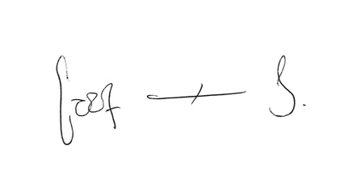

Cynthia Mora-Spencer ACG

Institute Secretary

**2 September 2024**

______________________________________________________________________________

**Notes not forming part of the resolutions**

1. The Council of the Institute has appointed Vistra as scrutineers of the annual general meeting for the purposes set out in the Byelaws.
2. In order to be passed, resolutions 1 and 2 require a simple majority of the members voting (e-voting, in person or by proxy) on a poll taken in such a manner as the person chairing the meeting directs.
3. A member entitled to participate and vote at the meeting may appoint a proxy to attend, speak and vote on their behalf. A proxy must be a member of the Institute who is entitled to vote.